**JSON API with Pandas orient='values'**

import pandas as pop

pp={"India":[ 1,2,3,4,5], "America":[8,9,10,7,3],"Europe":[6,8,3,6,5]}

census=pop.Dataframe( pp)

obj=pop.read_json ( 'population.json' ,orient='values')

print (obj)

obj.to_csv('res_values.csv')

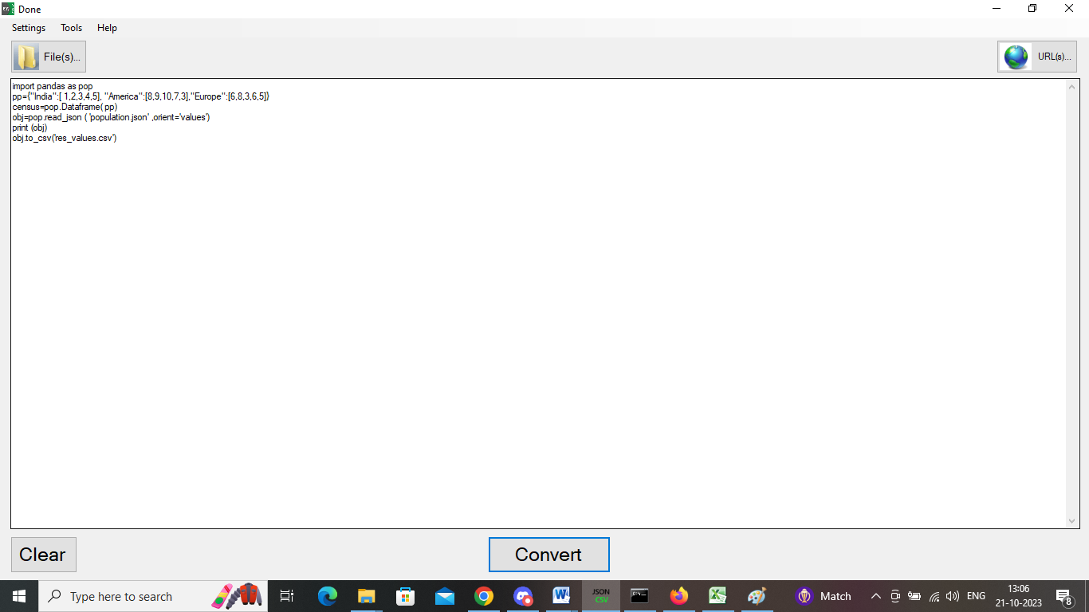

OUTPUT

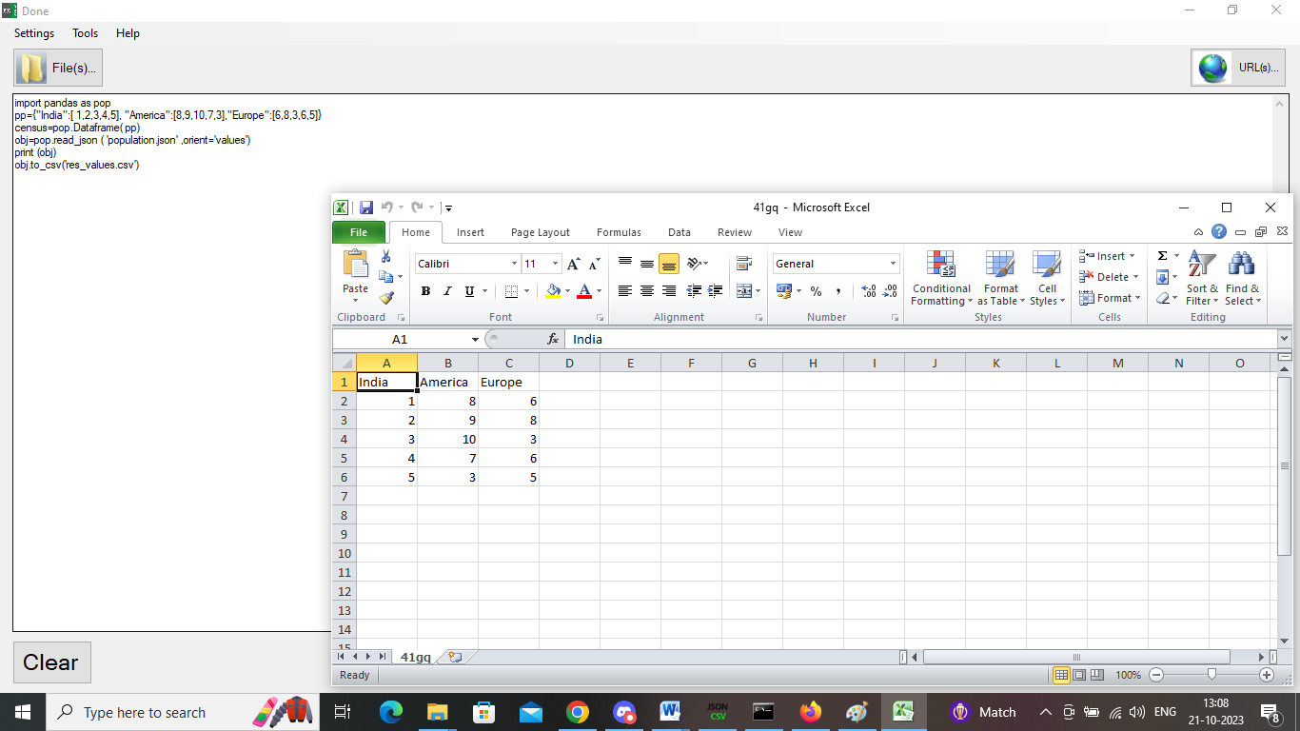

**JSON API with Pandas orient='records'**

import pandas as pop

pp={"India":[ 100000,200000,300000,400000,500000], "China":[800000,900000,10000000,700000,300000],"South Africa":[600000,800000,300000,600000,5000000]}

census=pop.Dataframe( pp)

obj=pop.read_json ( 'population.json' ,orient='records')

print (obj)

obj.index+=1

obj.to_csv('res_records.csv')

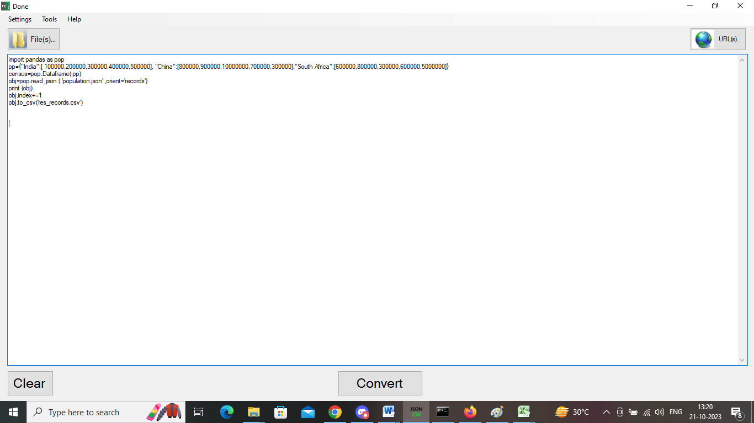

**OUTPUT**

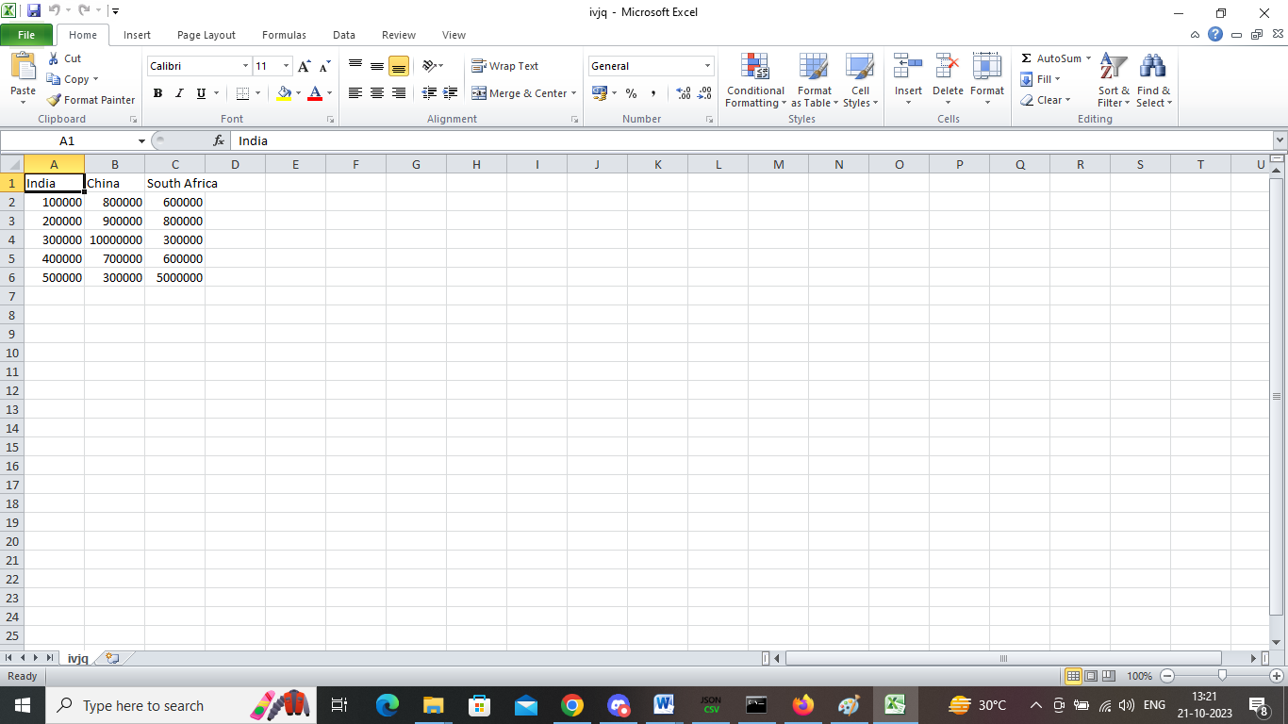

**JSON API with Pandas orient='split'**

import pandas as pop

pp={"India":[ 100000,200000,300000,400000,500000], "China":[800000,900000,10000000,700000,300000],"South Africa":[600000,800000,300000,600000,5000000]}

census=pop.Dataframe( pp)

obj=pop.read_json ( 'population.json' ,orient='split')

print (obj)

obj.to_csv('res_split.csv')

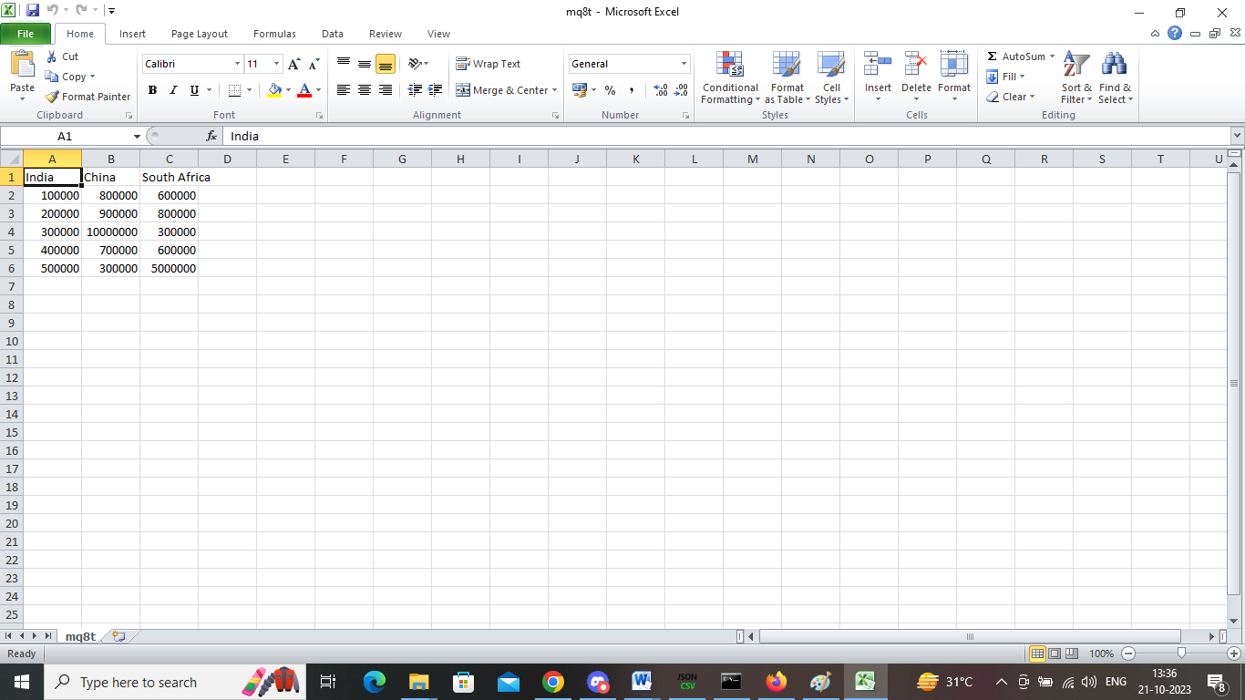

**JSON API with Pandas orient='index'**

import pandas as pop

pp={"India":[ 100000,200000,300000,400000,500000], "China":[800000,900000,10000000,700000,300000],"South Africa":[600000,800000,300000,600000,5000000]}

census=pop.Dataframe( pp)

obj=pop.read_json ( 'census.json' ,orient='index')

print (obj)

obj.index+=1

obj.to_csv('res_index.csv')

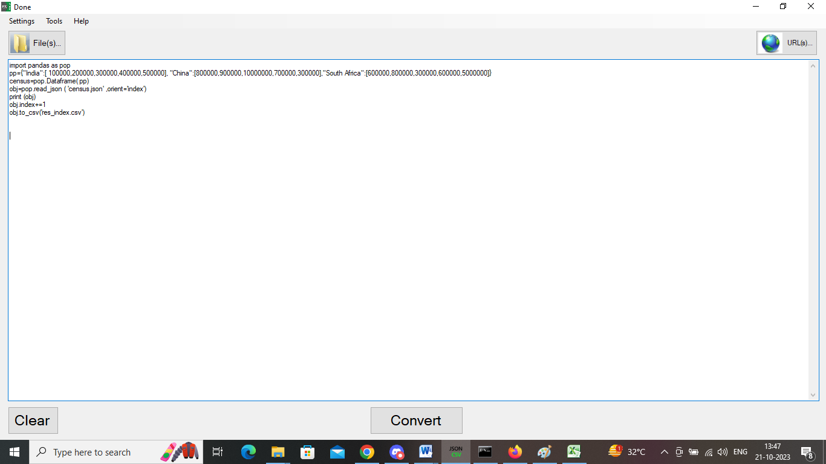

**OUTPUT**

